Nuclear Sustainability: Nuclear Power: For or Against?
Nuclear Facts:
- SONGS had Two 1127 Megawatt (1.127 GW) reactors. Total 2254 MW (2.254 GW)
- 4,000 Tons of waste are stored at SONGS currently (Wikipedia)
- With SONGS gone, there are now 100 Nuclear Reactors in USA They supply 790 TWH of electricity or 19% of our country’s needs (that means we use a total of 4200 TWh). Each of these nuclear reactors was built prior to 1977. There have been no new nuclear reactors in the USA since 1977 (Wikipedia)
- France has 59 Nuclear plants that make 407 TWh and that’s 75% of their country’s need (this means they use 542 TWh) for power. France has the largest % of power produced by nuclear plants of any nation. (Wikipedia)
- Yucca Mountain was a planned underground bunker built and constructed along the California/Nevada border in the 1980’s as an attempt to store spent nuclear waste from facilities across the United States. The progress of this has been held up in Federal acts and mandates as well as lack of funds.
Wind Facts:
- Wind energy makes up 2.3% of the electric power generation in the USA (Energy for Future Presidents)
- Over 100 million birds are killed each year by running into windows of buildings. The number of birds killed by turbines is much smaller! (Energy for Future Presidents)
- A typical 7-megawatt wind turbine is 650 feet tall (the statue of Liberty is 305 feet tall).
- Each SONGS reactor delivered 1127 MW. So, that would require 1127 MW/7 MW = 161 7-megawatt wind turbines to replace each of the two reactors. (calculation based on information from Wikipedia and Energy for Future Presidents)
- Each blade of the 7-megawatt wind turbine is 63 meters (206 feet). Turbines are spaced 5 to 10 times the blade diameter (which would be 63 x 2 = 126 meters). So, 5 times that space would be 630 meters apart.
Solar Facts:
- Solar energy makes up 0.16% of the electric power generation in the USA (Wikipedia)
- The new 5-megawatt Solar Tower Plant at State-line between California and Nevada has 24,000 mirrors pointed at a tower of molten salt. The molten salt is used to heat steam that in turn runs a turbine to generate electricity. To replace SONGS’ 2254 MWs, that would require 451 of these plants. (Energy for Future Presidents)
- Most solar plants produce about 250 watts (0.00025 MW) per square meter. (Energy for Future Presidents)

Assignment: In an 1150 word essay (3-4 pages; single spaced, 12 point font), write an argumentative paper using informed research which either shows your support for or against the use of nuclear power in the US.
Introduction paragraph – stating your position and outlining your argument. 4 body paragraphs. Conclusion.
You must cite at least 4 references and annotate using annotated bibliography formatting (nothing fancy, just list your sources and a brief explanation of the website). One of the four references must be from an opposing view of the one you are taking.This must be identified in your bibliography.
10% of the grade is neatness, organization and grammar/spelling. 10% of the grade is a bibliography. Turnitin.com receipt should be stapled to the back of your paper

- If you support the continuation of United States’ implementation of Nuclear Power then you must:
- Present feasible options for handling the spent nuclear waste (20% of the grade)
- Give evidence of the safety of Nuclear Power (20%)
- Cite environmental impacts (good and bad) of Nuclear Power (20%)
- How would you handle the public sentiment of those who oppose Nuclear Power? Discuss the drawbacks of other energy possibilities that would be used to replace Nuclear Power(20%)

- If you are against the continuation of United States’ implementation of Nuclear Power then you must:
- Cite environmental impacts (good and bad) of Nuclear Power (20%)
- Give feasible options to make up for the loss of power currently generated by Nuclear Power (20%)
- Discuss and defend a plausible alternative option(s) people could use to make up for the loss of power generated by Nuclear Power by showing statistical comparisons (20%)
- How would you handle the public sentiment about your alternatives not being as good as Nuclear Power(20%)

The San Clemente High School Chemistry Department has provided a Google Docs webpage where students may share your favorite URLs here for the Nuclear Sustainability Project. Feel free to add any favorite links you find during your research.

http://bit.ly/1tIu9FB

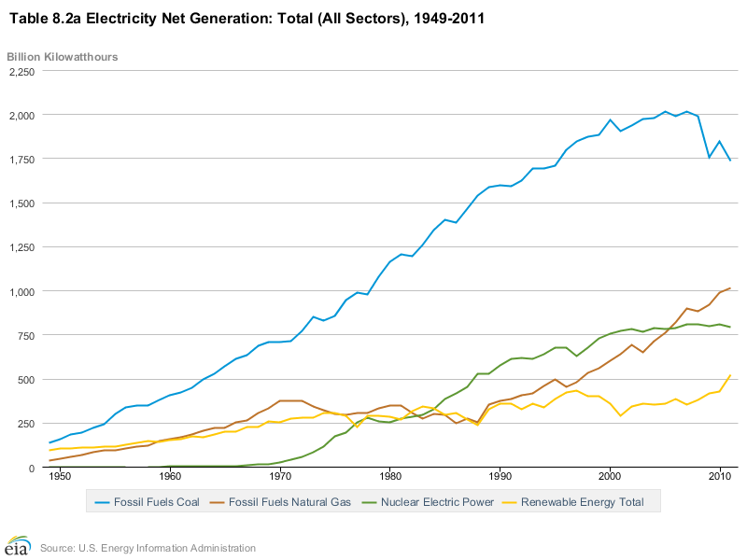
The graph below shows the amount of energy produced each year in our country by a variety of sources including: Coal, Natural gas, Nuclear and renewables (wind, solar, geothermal)

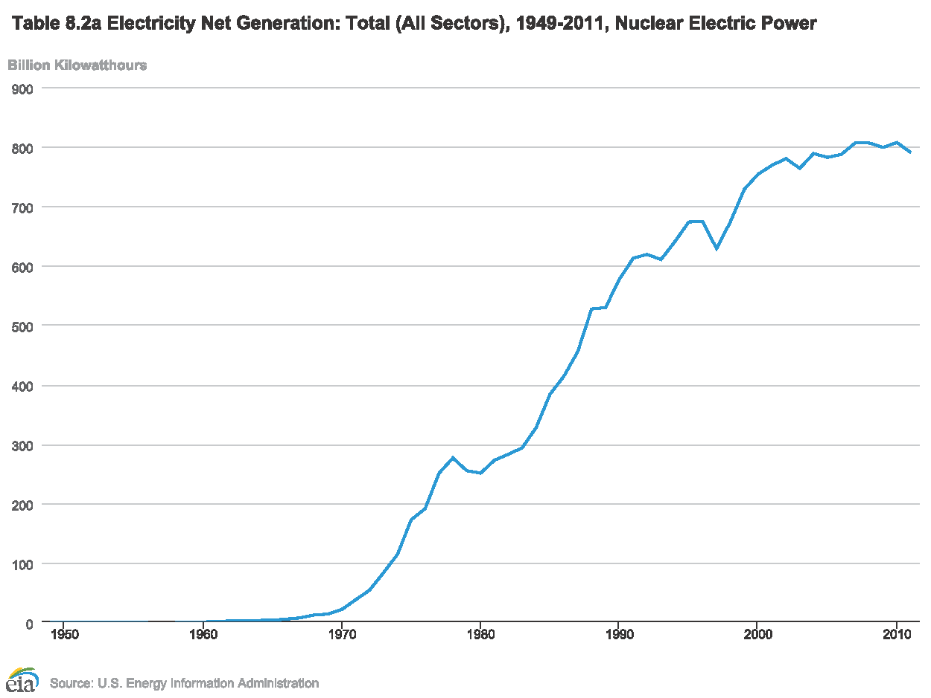
The graph below shows the amount mount of energy produced by Nuclear power plants in our country since they were first brought on-line in the late 1960s.

